1. Download & Start Apache & MySQL on XAMPP Control Panel

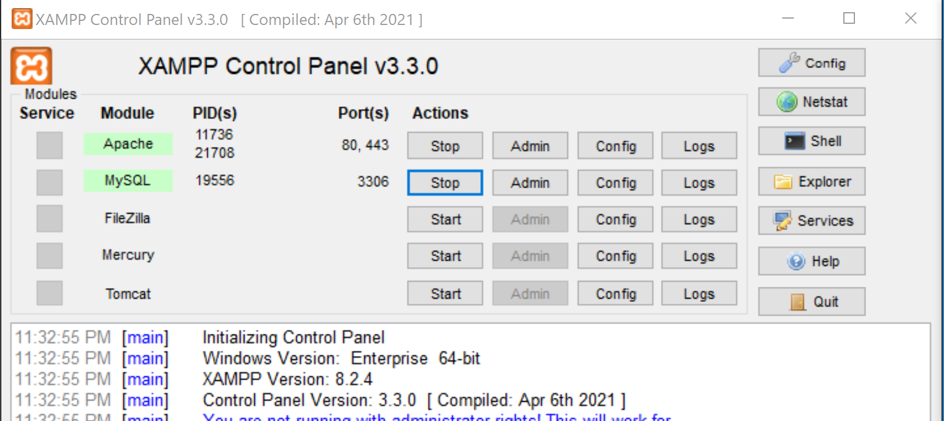

1. Create a database telemedvitals
2. Create table vitals with these properties.

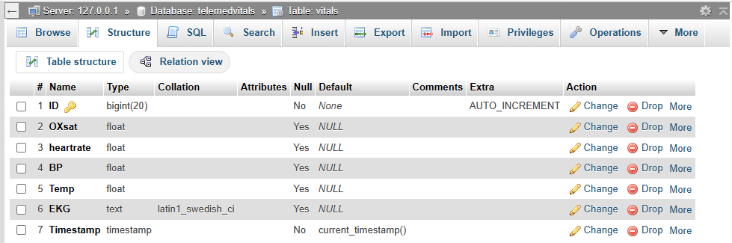

1. Install python2.7 (use this video tutorial <https://www.youtube.com/watch?v=cw4jLUGaQ9U&t=855s> )
2. Install this serial library <https://pypi.org/project/pyserial/3.4/#files>
3. use this version of my sql <https://sourceforge.net/projects/mysql-python/> or <https://sourceforge.net/projects/mysqlpythonwinx64py272/>
4. Run the python script.